### **Peace Dove Ornament**

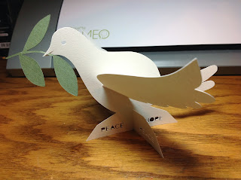

Desk model of peace dove ornament

I love this ornament. The dove is so pretty with the olive branch in its mouth.

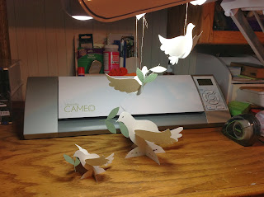

There is a fourth version here. I eliminated the olive branch in one of the hanging ornaments.